Outdoor educational activities in Dobrita, Secondary School.

The Secondary School from Dobrita is situated in the village with the same name, in Gorj county. Dobrita with a population of about 2000 inhabitants, it is 15 kilometres from Tg-jiu, in the north-western, part of Gorj county and is crossed by two rivers :Jiu and Sohodol.
Because here, there are the wonderful gorges of Sohodol, the village has a great touristic potential, which unfortunately is not so visited although it should be.
Dobrita is unfortunately situated in a socio- economically disadvantaged area because many miners have become unemployed and because there are many unemployed people, without a constant income, many of them receiving Gouvernmental help.
Although Dobrita is in the country the ground is not so fertile, so it can’t offer its workers a sufficient income to support the whole family.That’s why the families from Dobrita and therefore the pupils from here are in deep financial problems thus existing the danger of giving up the school. Lately there have been so more and more cases of families who are going abroad in EU countries, especially to work in order to earn their livings.
More and more families have been offered Gouvernmental support lately the general income of families being of about 150 RON/person.
There has been a more and more obvious difference between pupils studying in the country and the ones in towns. Less and less pupils which live in the country gave up the idea of receiving further education after High-School.Below is the picture of our school.
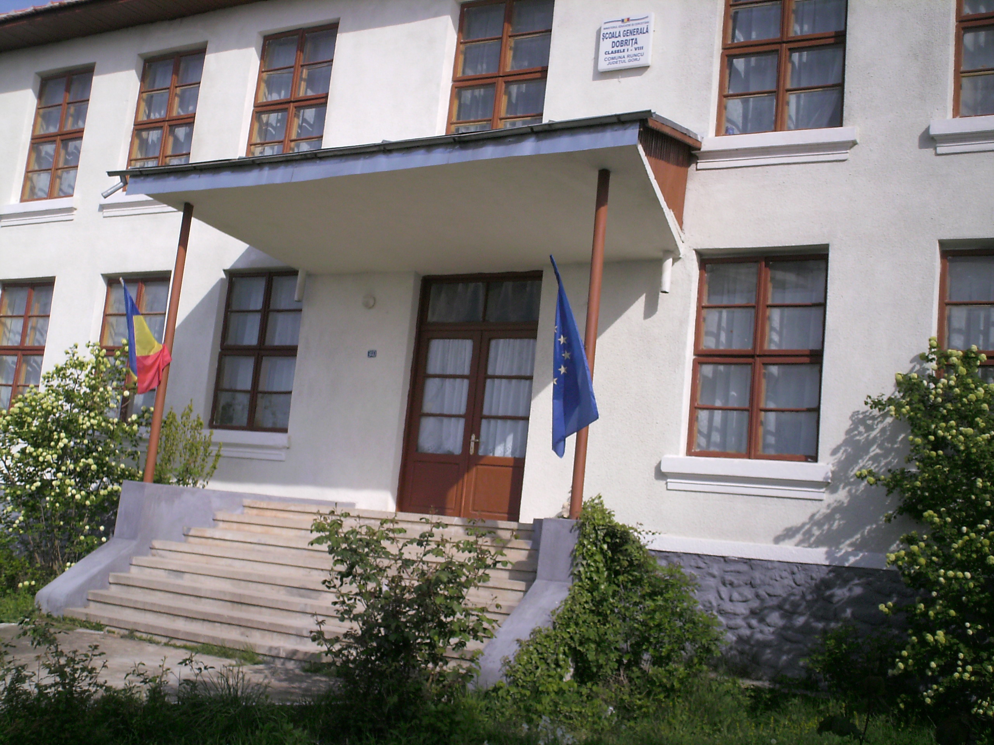
The students and teachers from the Secondary School Dobrita organizated many extra-school(outdoor) activities, which should be mentioned:

…….cultural activities(folk music and dances) on theme: “European folk music and dances” which has promoted an intercultural education describing the customs and traditions in this area, getting to know the culture of others European countries.
“The Spring Day In Europe”.
We have marked this activity every year, since 2005, in cooperation with the neighbour schools from Runcu, Arcani, and Balta through extraordinary entertainments containing: reciting poems, contests on general European history and constitutional knowledges , sport competitions, folk dances. Our school students have received prizes and diplomas, winning the 1-st place.
They danced in “a spring circle” symbolizing the European Union stars showing the Europaen union and integrity. A CD was realized containing the main activities with pictures and was sent to you via email.This year we will mark this activity on the 9-th of May, the Europe Day.

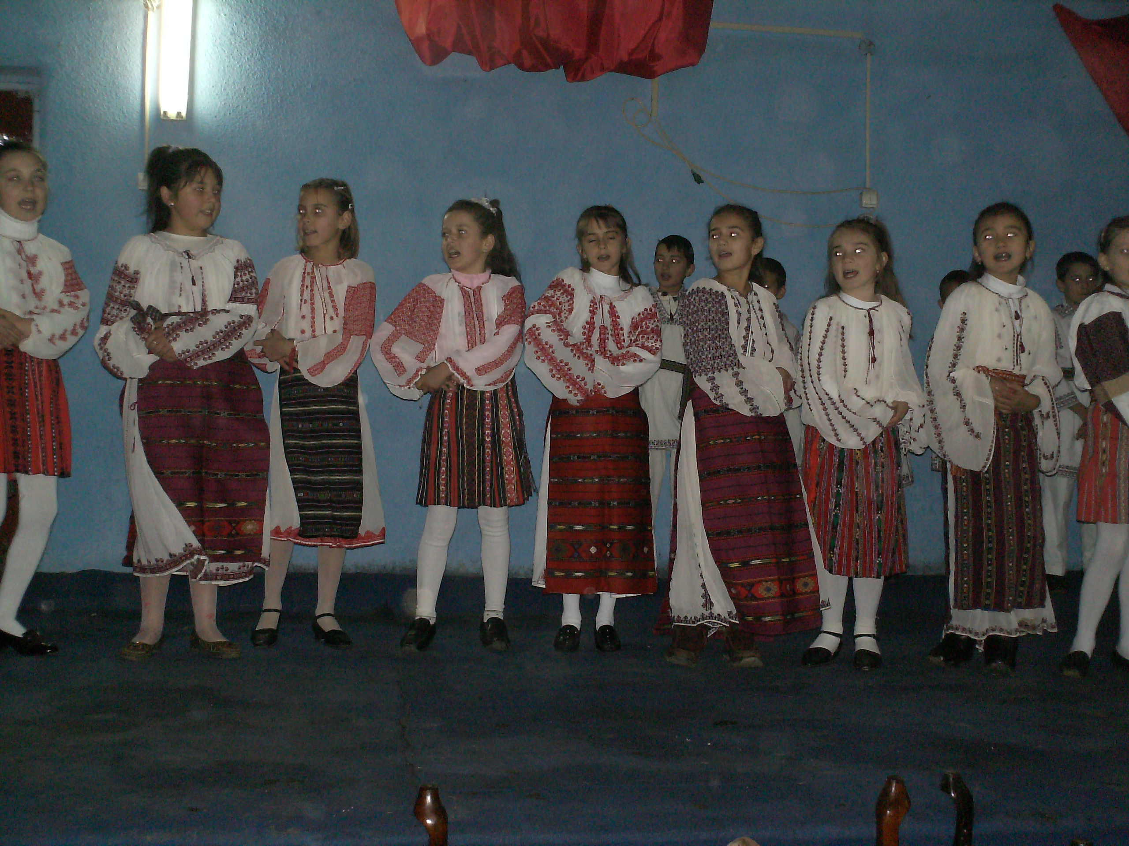………….sports competitions: football, volleyball, table tennis, chass, between other country schools, our school winning the 1-st place at football and table tennis.A kind of these activities could be on theme: “ Team working, solidarity, tolerance and fair play through outdoor, physical activities: football, tennis, voleyball” ”. This theme included all pupils, also those with special educational needs through physical activities, it involved male and female pupils in order to overcome the gender stereotypy, it also develop team-working, tolerance and solidarity for others by exchanging information on cultural activities among different ethnic groups, as well as, overcoming the racism, xenophoby(gypsies).

…………national and international projects;

e.g :- a national project was the one from the Rurallearn section, on theme: „The active-participative methods in teaching and learning sciences in the new and modern laboratories.”,which was running for nine months,(2006). Some pictures from this project activities was sent to you via email.

- an international (Socrates) project on theme : „Water in my Life”, seeing the natural water resources from this rural area. This project wanted to be a teaching project about the utilization and the exploitation of the water. In this experience different european schools from Italy, Romania,Portugal, Turky and Bulgaria, could discuss and confrontate their opinions about this important natural resource across cultural and pedagogical exchanges. So, pupils of the Lower Secondary Schools joint in partnership, met in different meeting projects or through Internet. Our aim was to educate the students to a conscientious use of this resource, knowing that its inadequate utilization is dangerous for the quality of human life. During the project activities the pupils and the parents were supported from experts and involved their families to know this complex problem. The project ended which: web sites, CD, DVD, brochures containing the results of project activities (questionnaires, photos, video-clips, analysis). A CD was realized, containing the main project activities with pictures made during:
-guided visits to springs, waterfalls, aqueduct fountains, collecting stations, decantation and filtration basins;
-different lessons in Science (Physics, Chemistry, Biology), Geography, English, Information Technology;
-the applied activities as part of lesson from school curriculum, named ”Water in my life”, meetings and round tables where were involved students, experts, teachers, authorities.

These were, generally, the main activities which took place in our school, but the students and the teachers of our institution are ready, anytime to engage in others new ones (local, national or international) from future projects.
Yours sincerlly,
Patrascoiu Ana-Maria-coordonator teacher.

